USB OTG

USB OTG introduces the concept of a device performing both master and slave roles

They can act either as a host, using the standard Linux-USB host side driver stack

or as a peripheral, using this "gadget" framework

The default for USB host is not , I will enable it in the kernel configuration.

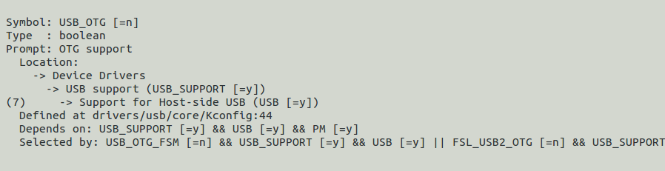

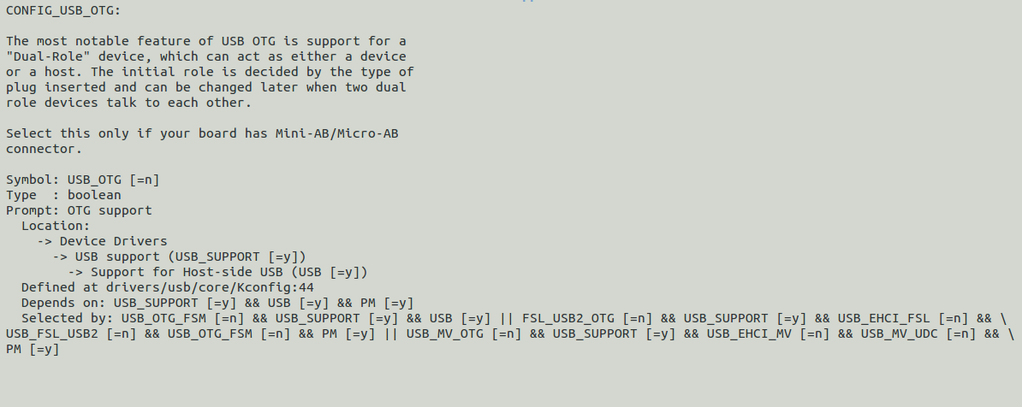

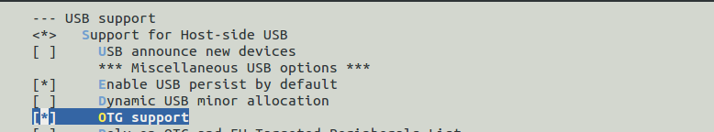

After enable it

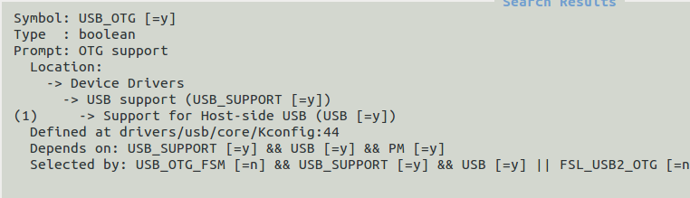

The USB OTG host side is now enabled.

The board does have

J1 – USB2 On The Go (OTG)

Connector, **Micro USB Type AB**, Right Angle, 5pin, SMD, P.N. ZX62D-AB-5P8, Hirose.

The mass storage is already define as a module

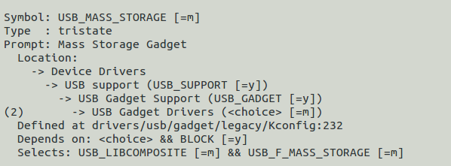

It looks like that the gadget side is enabled by default.

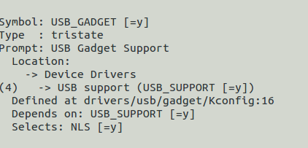

Device tree:

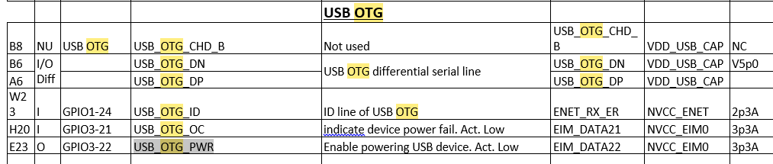

The last three:

USB_OTG_ID , ISB_OTG_OC and USB_OTG_PWR are define in the device tree:

What are those lines , I don’t know

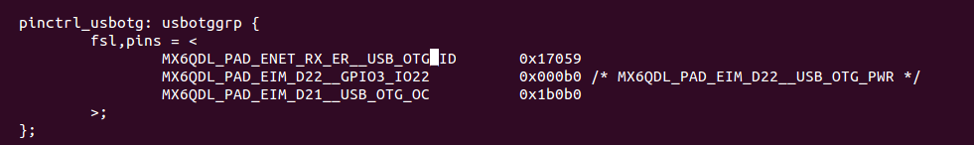

The CPU enable VBUS by setting USB_OTG_PWR to “0” (GPIO3-22, default

The CPU enable VBUS by setting USB_OTG_PWR to “0” (GPIO3-22, default). Going low of USB_OTG_OC (GPIO3-21) indicate device power fault. The CPU should disable VBUS in this case.

In Device mode the VBUS power should be disable by setting USB_OTG_PWR line to “1”.

Other CPU USB Host ports are not used

***VBUS:***

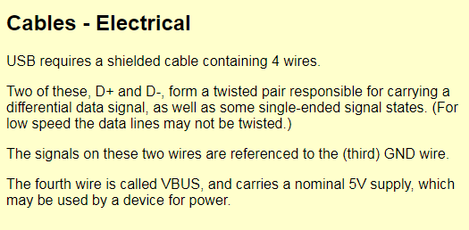

The two lines



Are part of the USB Cable ( D+ and D -)

From the device tree it looks like that the chip is configure correct.

But it will be nice to get more info from the hardware engineer.

Testing

**As USB Host:**

I plugged a WD hard drive with linux EXT4 file system

sudo mkdir /mnt/mydisk/

sudo mount -t ext4 /dev/sda1 /mnt/mydisk

Than I can view the files on the disk!

**As a mass storage:**

I need to connect some where the Linux to a micro usb to a linux PC – Ubuntu

And view the linux as a mass storage.

In the EVK there are several connectors , I don’t know which one , so for now I will not plug it to test.

The mass storage is a loadable module , so I don’t know yet if I need to load the module using a modprobe or it will be loaded automatically.